The below requirement is applicable to KRT system.

Requirement:

1. Delivery note should be changed to A4 Size format (Earlier they were using Dot Matrix printer)
2. We need total of 4 copies and each copy must specify the name at the header of Printout.

* 1st Print (Header Name) - Customer Copy
* 2nd Print (Header Name) - Driver Copy
* 3rd (Header Name) - Security Copy
* 4th (Header Name) - Warehouse Copy

1. Remove the “No of sets” column in existing format
2. Customer code which is at the right side should be moved under Consignee column of left side.
3. No of pages should be displayed in each printout
4. In reprint option needs to have the selection of DN page printout.

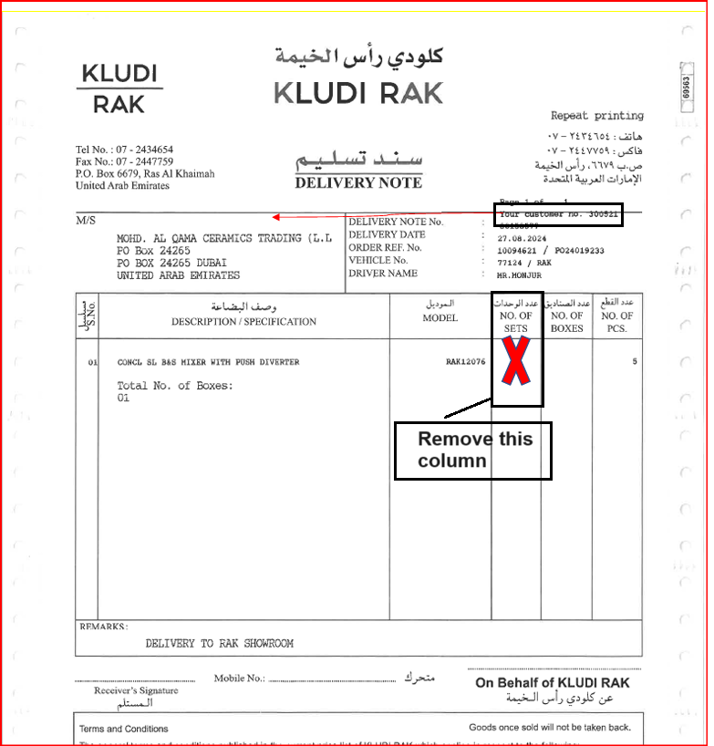

**How do they print the Delivery note?**

When they confirm the transfer order using LT12 t-code, delivery note printout is automatically generated.

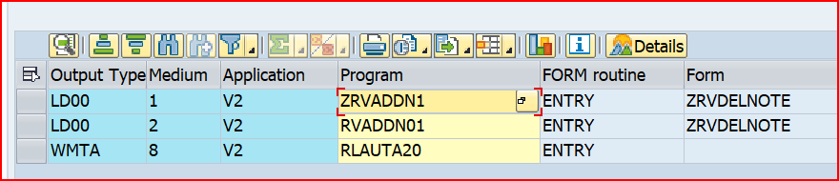

New changes received:

As the current delivery note is in SAP Script, it will be convenient if we change it to smart forms.

1. Header & Footer to be worked upon and it will be a static one
2. Layout alignment to be done

|  |  |  |  |  |
| --- | --- | --- | --- | --- |
| **Sr No** | **Development points** | **Tech Efforts (Hrs)** | **Functional Efforts (Hrs)** | **Total Hrs** |
| 1 | Existing efforts spent to create copies and worked on the correction of columns | 30 | 10 | 40 |
| 2 | Changing from SAP Script to smart forms | 36 | 0 | 36 |
| 3 | Building up the header & Footer & layout corrections | 4 | 0 | 4 |
| 4 | FUT Preparation and Testing | 0 | 20 | 20 |
| 5 | UAT observations (if any) | 0 | 10 | 10 |
|  | **Total Efforts (in Hrs)** | **70** | **40** | **110** |



Sample DN:

